**Ideation Phase**

**Empathize & Discover**

|  |  |
| --- | --- |
| Date | 25-05- 2025 |
| Team ID | LTVIP2025TMID55946 |
| Project Name | Docspot |
| Maximum Marks | 4 Marks |

**Empathy Map Canvas:**

An empathy map is a simple, easy-to-digest visual that captures knowledge about a user’s behaviours and attitudes.

The **Empathy Map Canvas** is a collaborative tool used to better understand the needs, emotions, and behaviors of the end users. It helps in **developing user-centric solutions** by exploring various aspects of user experience and perspective.

**Example:**

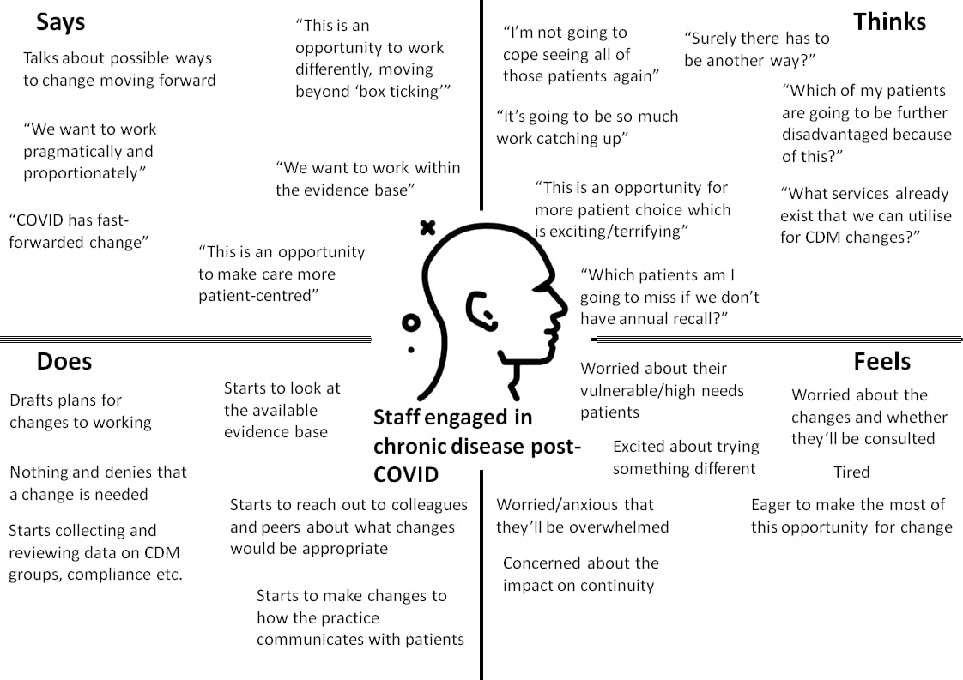

Reference: <https://www.mural.co/templates/empathy-map-canvas>

**Example: Fat patients in Ontario**

